***Onion cultivation is a very profitable business. Onion plant can be cultivated as a monocrop or intercrop. Here is the complete guidance on onion farming including onion growing conditions, season, seeds, diseases and harvesting.***

## Ideal Conditions for Onion Cultivation

Onion needs a temperate climate and alluvial soil to grow in. Depending on the onion growing time and place of cultivation, onion can be grown as long day onions (for plains) or short day onions (ideal for hilly regions).

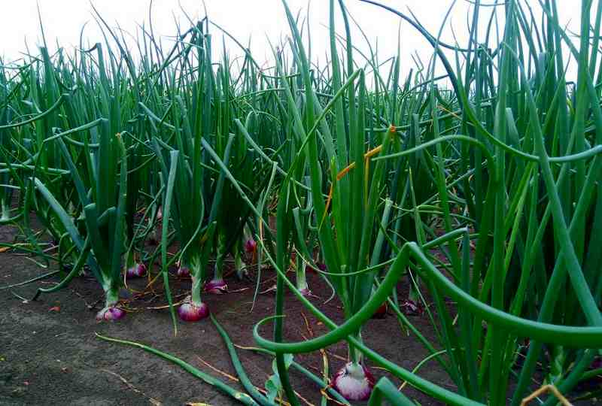Onion farming

### Climate for Onion Farming

Although it is a temperate crop, onion cultivation can be possible under sub-tropical, temperate or tropical climate. A mild, gentle weather that is not too rainy, too cold or too hot is ideal for onion growing. However, it can withstand extreme weather conditions at younger stage. Short day onions that need 10-12 hours of day length are grown in plains while long day onions requiring 13-14 hours of day length are grown in the hilly areas.

Onion crops need lower temperature and shorter day light (photoperiod) for vegetative growth while during the bulb development and maturity stage it needs a higher temperature and longer day light. Other requirements for onion cultivation are:

## Land Preparation for Onion Farming

Onion can grow in almost all types of soils. Generally, the seeds are sowed in nursery and the seedlings are transplanted after approximately 30-40 days. Before transplantation the field must be ploughed properly to get rid of the soil clods and unwanted debris. Vermicomposting (approximately 3 tonnes per acre) or poultry manure can be incorporated. This is done during the last ploughing.

After ploughing the fields are levelled and beds are prepared. Depending on the season, the beds maybe flat beds or broad bed furrows. Flat beds are 1.5-2 meter in width and 4-6 meter in length. Broad bed furrows have a height of 15 cm and top width of 120 cm. The furrows are 45 cm deep so as to get the right spacing. Onions are cultivated in broad bed furrows during kharif season since it is easier for excess water to drain out through the furrows. It also facilitates aeration and reduces occurrence of [Anthracnose](https://www.farmingindia.in/anthracnose-disease/) disease. Flat beds are made if onion cultivation is done during rabi season. Flat beds for kharif can cause water logging.

## Planting Onion

Onion seeds are first sown in nurseries and later transplanted to the open fields. Nursery management and transplanting are hence the most important steps in onion cultivation.

For one acre of onion plantation, seedlings can be prepared in 0.12 acre of area. The nursery field must be ploughed well and made free of clods. The soil must be reduced to finer particles so as to hold enough water. The filed must be clear of stones, debris and weeds. Just like the main field preparation, farm yard manure (half ton) must be applied at the time of last ploughing. Raised beds are recommended for nursery preparation.

### Seed Preparation

Seeds are treated with 2g/Kg of thiram or Trichoderma viride to prevent damage from damping off diseases. The seed distance is maintained at 50-75mm to facilitate easy weeding and removal of seedlings for transplantation. The seeds are covered with farm yard manure after sowing and watered slightly.

### Transplantation

Onion seeds are first grown in nurseries and then the seedlings are transplanted to the fields 30-40 days later. 3-4 Kg seeds are needed for one acre of field. Early transplantation yields more bulbs. During transplantation, care must be taken to avoid over and under-aged seedlings. The following process is followed during transplantation:

* About one-third of the top of the seedling is cut
* Roots are dipped in 0.1% carbendazim solution for two hours to prevent fungal diseases
* The seedlings are transplanted into prepared beds at a distance of 10 cm between plants.

**Common Diseases that attack onions:**

### Insect Diseases

| **Pest Name** | **Identification** | **Symptoms and Nature of Damage** | **Control Measures** |
| --- | --- | --- | --- |
| Thrips (Thrips tabaci) | * Adult thrips are yellow to black colored with 4 wings * Immature thrips have white color body with no wings | * Infestation caused upto 45 days after transplanting * Leaves twist and curl * Silvery, white patches on leaves * Plants are blemished and white in severe cases | * Intercropping with maize or sugarcane is one of the best methods of controlling thrips * Insecticides must be sprayed when the thrips population cross 30 per plant |
| Eriphyid mites | * Microscopic mites that pinkish to purple in color * Difficult to identify with naked eye unless there ia a colony of the mites | * Yellow mottling along the edge of leaves * Leaves do not open completely * Plants curl up | * 0.05% Sulphur spray * 0.2% dicofol as soon as symptoms appear and then every 15 days thereon |

### Fungal Diseases

| **Disease Name** | **Causative Agent** | **Symptoms and Nature of Damage** | **Control Measures** |
| --- | --- | --- | --- |
| Damping Off | Water soaking | * Seedlings topple after emerging from soil * It occurs at ground or below ground level * Infected tissues appear soft and water soaked | * Planting onion on a raised bed * Treating the seeds with Thiram * Drenching the nursery beds with 0.2% Captan or 0.1% Carbendazim or 0.3% Copper oxychloride |

### Viral Diseases

| **Disease Name** | **Virus Name** | **Symptoms and Nature of Damage** | **Spread of Disease** | **Control Measures** |
| --- | --- | --- | --- | --- |
| Onion Yellow Dwarf | Onion Yellow Dwarf Virus | * Infected leaves develop yellow streaks that spread progressively leading to yellow leaves * Leaves curl and plants wilt * Bulbs do not grow to full size although they are firm and solid | Spread mainly through aphids | * Use of resistant variety * Selecting healthy plant material for sowing * Controlling aphids through inter-cropping * Spraying insecticides like 0.1% Profenofos, 0.2% Carbosulfan or 0.1% Fipronil can control Aphids |
| Irish Yellow Spot | Irish Yellow Spot Virus | * Leaves show lesions that maybe diamond or spindle-shaped * They are straw-colored * Sometimes they have distinct green center with yellow borders * Flower stalks are infected in later stage | Thrips | * Transplants must be checked for thrips invasion and diseases * At least three years of crop rotation is advised for preventing this disease * Crop stress must be avoided * Controlling thrips is to extent seen effective in controlling the disease. |

## Onion Harvesting

Onion harvesting is done when the still green tops start drooping. The plants are gently pulled out from the soil. However, 10-15 days before harvesting irrigation of the field is stopped. The crop is also sprayed with 1000 ppm carbendazim 30 days before harvest. This helps increase the shelf-life of the crop. The bulbs are cleaned and dried in shade for 4 days.

## Onion Grading

After harvesting, the bulbs are graded according to their size as A (more than 80mm), B (50-80 mm) and C (30-50 mm).

## Onion Storage

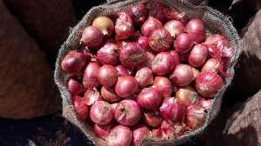Onion storing in jute bag

Generally, onion bulbs harvested in rabi season have better shelf-life than kharif. Light red onion varieties have better storage potential than the dark red varieties. They are stored in jute bags or wooden baskets. They are also stored in netted bags. This is important because onions emit gas which if may lead to rotting if not allowed to escape. Optimum temperature for storage is 30-35˚C with 65-70% relative humidity.

Cold storage increases the shelf life. The loss of crop after storing in cold for six months has been found to be 5%. However, extremely low temperature (less than -2⁰C) can lead to freezing injury. A high temperature can cause rotting. A gradual decrease of temperature prevents microbial decay.

## Conclusion

In the recent years Uganda faces a shortage in onion on a yearly basis and this triggers price rise. Therefore, onion cultivation can be a huge money making agribusiness.

Reference

1. <http://apeda.gov.in/apedawebsite/SubHead_Products/Onions.htm>
2. <https://en.wikipedia.org/wiki/Onion>
3. <http://www.centerchem.com/Products/DownloadFile.aspx?FileID=6784>
4. <http://dogr.res.in/index.php/en/onion>
5. <http://agritech.tnau.ac.in/horticulture/horti_vegetables_small%20onion.html>
6. <http://www.krishisewa.com/crop_system/varieties/vegetable-varieties/596-varieties-onion.html>
7. <http://vikaspedia.in/agriculture>